Name: Aimee Steinwand

A Description of the project and questions of interest:
The goal of this study is to compare survival between two treatments for ovarian cancer. There are 26 women assigned to one of two treatments. Please assess whether the survival time is longer in one of the two treatments compared to the other.

Each line of the data set has an identification number and provides information on the other variables for each person.
Column 1: futime:time survived in days after diagnosis
Column 2: timefustat:censoring status (0 = censored, 1 = died)
Column 3: age: in years
Column 4: resid.ds:residual disease present (1=no,2=yes)
Column 5: rx:treatment group
Column 6: ecog.ps:ECOG performance status (1 is better, see reference)

The data for this worksheet is an R dataset called ovarian.

Part 1: Orienting yourself to the analysis

- What is the outcome for this analysis?

Time to death after ovarian cancer diagnosis.

- What is(are) the primary variable(s) of interest for this analysis?

Treatment group, the two ovarian cancer treatments being compared.

- What method will you use to estimate and compare survival between the two treatment groups?

Kaplan–Meier survival curves to estimate survival functions for each treatment group.

- What types of descriptive statistics do you want to compute to assess the data and describe the data? How would you put this information into a Table in a report?

Descriptive statistics for continuous variables: age, time to death
- Mean, sd, median, range
Categorical variables
- Counts and percentages
- What types of graphs do you want to create to assess and describe the data? What are you looking for with these graphs?

Graphs:
- Kaplan–Meier survival curves for each treatment group
- Boxplots
What to look for:
- Whether one treatment curve stays above the other (suggesting better survival)
- Where curves diverge
- Whether censoring is balanced
- Median survival times
- Whether curves cross

- Draft a bullet point introduction and preliminary analysis plan.

Introduction:
- Ovarian cancer treatment effectiveness is often evaluated using survival outcomes.
- This study compares survival between two treatment groups in a dataset of 26 women.
- The primary objective is to determine whether one treatment leads to longer survival.
- Survival analysis is required because some patients are censored

Preliminary Analysis Plan
- Compute descriptive statistics for baseline characteristics by treatment group.
- Estimate Kaplan–Meier survival curves for each treatment group.
- Compare curves visually and using the log‑rank test.
- Report median survival times and 95% confidence intervals.
- Assess censoring patterns and ensure assumptions

- Compute the Kaplan-Meier estimated survival curve for those on treatment = 1. Verify the first few estimates by hand. The goal is to practice and understand how the K-M estimator works.
library(survival)

group1 <- subset(ovarian, rx == 1)
fit1 <- survfit(Surv(futime, fustat) ~ 1, data = group1)
summary(fit1)

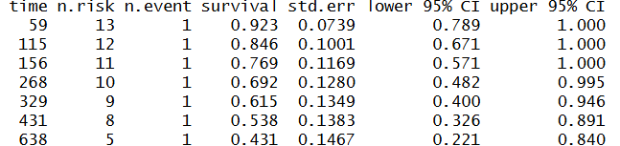
- Estimate the survival curves for each group.

fit_rx <- survfit(Surv(futime, fustat) ~ rx, data = ovarian)
plot(fit_rx)

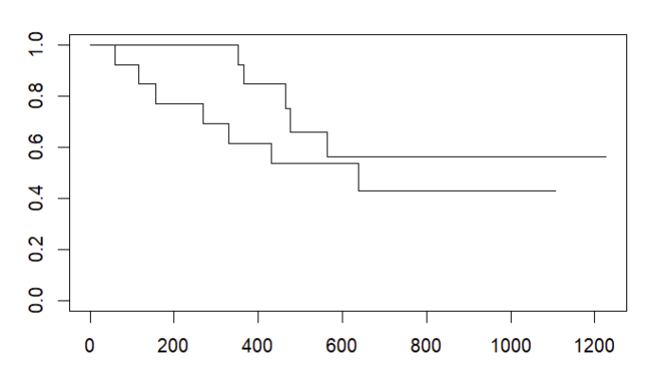

- Write a basic summary of your prelim analysis.

